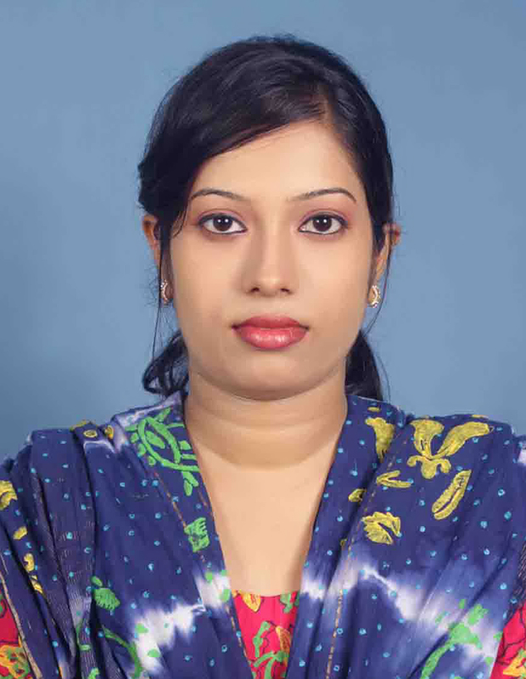
CURRICULUM VITAE

Ayrin Parveen
G.P. cha-171, Mohakhali
Dhaka-1212, Bangladesh
Cell: 01676-261089
E-mail: shumi_law@yahoo.com

CAREER OBJECTIVES:
To prove myself as an excellent professional in the company which provide dynamic and challenging opportunities for personal developments and to contribute towards both corporate and personal growth.

WORK EXPERIENCE:

Coustomer Relation Officer (CRO):
Company: ECM Auto Center Ltd.
222, Gulshan- Tejgon Link Road, Dhaka-1208
From: 1st June, 2011– present

Job Responsibility:

- Convincing customers regarding any query and problem of organization’s services;
- Tele marketing
- Preparing commercial invoice & documentation;
- Make bill documents & maintain daily cash;
- Arrange document customer’s demand;
- Confirmation that some fact or statement is true through the use of documentary evidence
- Satisfy customers & ensure that customers will come again for service.

ACADEMIC QUALIFICATION:

L.L.M. :
Result-Not yet published
From - Rajshahi University
Exam held in -1212

L.L.B.:

Result- CGPA: 3.08/4.00 Scale
From Rajshahi University
Passing Year-2011

HIGHER SECONDARY CERTIFICATE (HSC):
Result- GPA: 4.80/5.00 Scale
Background-Commerce
From Cant. Public School & College, Bogra.
Under the board of Intermediate & Secondary Education, Rajshahi.
Passing Year-2005

SECONDARY SCHOOL CERTIFICATE (SSC):
Result-GPA: 4.25/5.00 Scale
Background-Huminities
From Bogra Govt. Girls High School, Bogra
Under the board of Intermediate & Secondary Education, Rajshahi.
Passing Year-2003.

COMPUTER LITERACY :
MS-Office.
XP, VISTA & WINDOWS 7.
Adobe Photoshop.
Internet Browsing.

LANGUAGE KNOWN :
English (Both written & spoken),
Bengali (Both written & spoken),

STRENGTH :
- Self-confident
- Hard working
- A modest congenial and sociable person
- Ability to work in Groups
- Willingness to accept directions
- Fast to learn new things from others
- Strong willpower
- Experience in analytical thinking, problem solving and stress minimizing aand conflict resolution

HOBBIES :
- Listening music,
- Travelling,
- Surfing Internet,
- Reading Novels,

OTHERS:

- I am a member of Red Crescent Society

- I have completed my Girls Scout Course

PERSONAL PROFILE :

Name : Ayrin Parveen

Father’s Name : Md. Abdur Rahman

Mother’s Name : Mst. Sirajum Monira

Present Address : G.P. cha-171, Mohakhali
Dhaka-1212, Bangladesh

Permanent Address : Castle De Khaled, Malotinagar (Boro Bari )
Ward No.7, Post-Bogra 5800, Dist-Bogra, Bangladesh

Date of Birth : 26 january,1989

Age : 23 Years old

Religion : Muslim

Nationality : Bangladeshi (By Birth)

National ID No. : 1022007062274

Marital Status : Unmarried

Sex : Female

Blood Group : B+ (Positive)

DECLARATION :

I hereby declare that all the above furnished information is correct to the best of my knowledge and established records.

Date :

Place : Dhaka.

(Ayrin Parveen)

REFERENCES :

Syed Nasir Alam
Advocate & Legal Advisor TMSS, Bogra
Cell: 01714-494959
Tel: 051-78792

Md. Khaledur Rahman
Assistaant General Manager,
DJ Agro Ltd.
Cell : 01937-911920
E-mail: khaled@djagroltd.com

